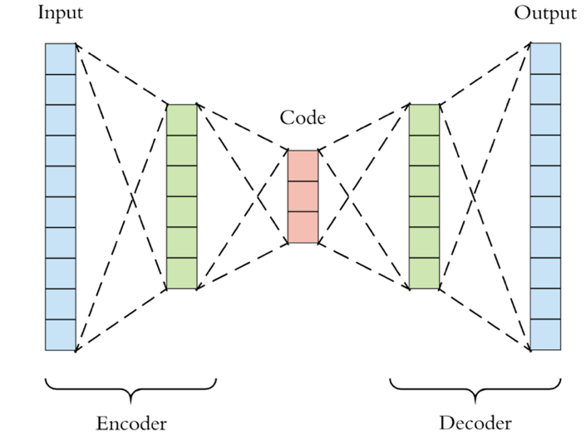

**Artificial Lineup Facial Generation**

**An Overview**

Eyewitnesses play an important role in the justice system. Testimony from an eyewitness can influence the direction of an investigation, shape the contours of a prosecutor’s arguments, and - perhaps most importantly - sway the hearts and minds of jurors hearing a given judicial case. For better or for worse, eyewitness identification *acts* like proof.

*“… there is almost nothing more convincing [to a jury] than a live human being who takes the stand, points a finger at the defendant, and says 'That's the one!'”*

- U.S. Supreme Court Justice William J. Brennan

zzzs

Our team developed a novel solution with the potential to greatly reduce eyewitness misidentification by heeding the above recommendations and marrying them with recent advances in artificial intelli-gence and computer vision.

Rather than seeking to displace an entrenched, well-understood process, we seek to make the existing lineup pro-cess better. With our system, all one needs to conduct a rigo-rous lineup procedure is a suspect headshot, a smart-phone, and an eyewitness.

First, the system - accessed like any other app on a device - consumes the headshot of the suspected perpetrator. From that image, the system gen-erates a series of synthetic headshots that each bear a resemblance to the suspect. After careful automated screen-ing for quality and similarity, the system curates a set of looka-like portraits. This is the lineup.

Before the eyewitness has a chance to inspect the lineup, these images are shuffled and de-identified to guarantee that the lineup is blind for both the …

**The Challenge**

The United States has the world’s largest prison popula-tion, both gross and per capita. *The Innocence Project*, a non-profit dedicated to exonerating the wrongly convicted, estimate approximately 20,000 inmates are wrongly incarcerated at this time. Each year, they estimate, the problem grows: between 1% and 5% of new convicts are innocent.

Furthermore, they have found that **eyewitness mis-identification is the leading cause in over 70% of wrong-ful convictions**, especially in the many cases where forensic evidence, such as DNA or fingerprints, was initially lacking or otherwise ambiguous.

Despite its shortcomings, an eyewitness’ testimony is pow-erful evidence, and thus will continue to occupy a prominent place within the criminal justice system.

by Brandon Harris, Harper Pack, and Ikhlas Attarwala

**Case Study: Northwestern MSAI**

**Our Solution**

Legal experts on this topic, such as those at the Innocence Project and the National Center for State Courts, have identified 6 best practices essential to decreasing the incidence of wrongful convictions due to eyewitness testimony. These re-commendations aim to improve on the traditional police lineup:

1. Lineups should be created for only 1 suspect at a time.
2. Lineups should present suspects sequentially, rather than all at once.
3. Lineups should consist of individuals bearing a close resemblance to the suspect.
4. Lineups should be “double-blind”, where the identity of the real suspect is unknown.
5. Lineups should proceed with a standard set of instructions which clarify that the suspect may or may not be present in the lineup.
6. Lineups should immediately conclude with a confidence assessment, where the eye-witness evaluates the confi-dence in their identification (if one were made).

This assignment was granted an

extension until Dec. 9th, 7:00pm.

© 2019 Northwestern University, MSAI | All rights reserved.

**More on VAEs**

Autoencoders (AE) have two main phases. In the first, they encode images into a smaller, low-dimensional vectorized “latent space”, that learns latent features about the image. Afterwards, a decoder takes a point in the latent space and generates an image from it with the features encoded by the latent vector. In a variational autoencoder (VAE), a special loss function enforces meaningful structure in the latent space. This is so points in the latent space that do not correspond with training inputs can still be extrapolated to reasonable images. Proximity in the latent space corresponds approximately with having similar features in the decoded image.

* Authorities can rely on a best-practices process to help ensure investigative procedures are defensible and robust.

Ultimately, helping auth-orities run better investigations and aiding eyewitnesses in making accurate observations means fewer mistaken identi-fications and fewer wrongful convictions.

**Limitations**

There are a few limitations that are inherent to this system. The most important is that the system does not explain its choice of faces for the lineup - it is not deliberating as a human might. Further, it makes no guarantee of a process: as with any tool, it can be misunder-stood or misused.

**Considerations**

There are several important considerations when designing such a system. First, the system is predicated on a commitment to the integrity of the investigative process and the rights of individuals. As such, it must be construed as a tool, not an entity, such that it shouldn’t influence or shape the investigation beyond its instrumentality. Second, the system must provide repre-sentative lineups regardless of the suspect’s demographics or individual appearance so as to not to demonstrate even the appearance of bias. Finally, the system must not compromise …

the privacy of the individuals whose facial data trained the system, which could invite legal repercussions or produce the appearance of impropriety.

**Future Work**

Given the constraints of this project, our current deliverable falls short of our ideal. Our system trained solely on white, male portrait images, and so of course we must acquire more data that includes a larger distribution of skin tones, facial structures, genders, and portraits with atypical facial features. A more flexible system that can take in a wider range of input images including variations in light, facial angle, expression and composition would also yield better results, as would a more flexible output to generate lineups with features such as beards, piercings, tattoos, etc.

We created a very simple architecture to reduce computational load, but with longer training and a deeper network, we could yield higher-fidelity results. Finally, further experimenting with the architecture of the VAE may prove useful; recent research has shown that progressively training from lower resolutions and adding higher resolutions with each layer solve problems commonly associated with generating high-quality, large images that appear more believable and realistic.

administrator and the partici-pant.

Now the eyewitness is ready to begin the identification process. The system first provides a simple, instructions page, explaining that the wit-ness can swipe through photos one at a time in search of the suspect, who may or may not be in the lineup; upon making an identification, they will be prompted to evaluate their confidence in that identification.

The eyewitness is thus prepared to scrutinize the sus-pect candidates and consider making an identification. At the process’ conclusion, authorities have a firm result: either no identification, or an identifica-tion with clear documentation of eyewitness confidence.

**Impact**

This solution makes minimal yet meaningful changes to the eyewitness procedure. These adjustments result in material benefits for both eyewitnesses and authorities:

* Eyewitnesses are challen-ged to make identifications based on real recognition, not mere resemblance helping to **minimize false identifications**.
* Eyewitnesses make a just-in-time evaluation of their confidence, helping to better **qualify the nature of the identification**.
* Authorities can produce **high-quality lineups on-the-fly**, using **just a sma-rtphone**.

This assignment was granted an

extension until Dec. 9th, 7:00pm.

© 2019 Northwestern University, MSAI | All rights reserved.